Ping Sweeps:
ICMP Request (type-8 echo requests)
The host reply with (type-0 echo reply) then it is alive.
Ping ip address /domain name

Successful ping look alike as:
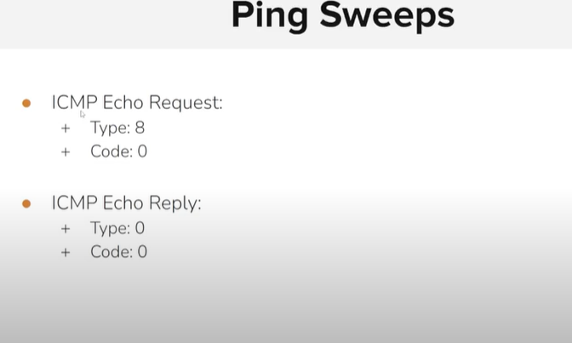
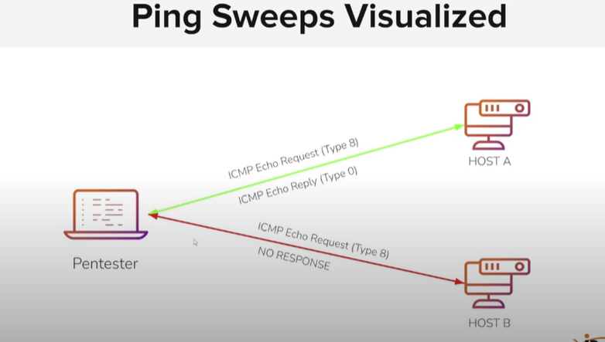

Some operating system or firewall does not reply to the echo request it does not means that the host is down or not. Such as in the window.

Nmap ip address
To check that the system is alive of not if no response comes then
(In linux terminal) Nmap -c 5 ip address
(in window terminal) nmap -n 5 ip address.
5 means it send 5 request.
It could be block due to network ,network configuration ,firewall ,host configuration specifically the os run on the host.

To set the interface on the wireshark :
Sudo wireshark -I eth0

Another tool for host discovery:fping

NOTE:
ping cannot ping a subnet (/24 or similar) — it only works with individual IPs.
Use tools like nmap or fping to scan a whole subnet.

Demo:
As iam scanning my window machine:



Fping -a -g ip-addess/25

Option | Meaning
-g | Generate a list of IPs in the specified subnet (e.g., /25 = 128 addresses)
-a | Only show alive (responsive) hosts — IPs that reply to ping

For check the subnet.

Fping -a -g ip-addess/25 2>/dev/null
2>/dev/null
Part | Meaning
2 | Refers to file descriptor 2, which is stderr (standard error)
> | Means redirect
/dev/null | A special file that discards everything written to it (like a black hole)

It redirects error messages (stderr) to /dev/null, meaning:
- Any errors will be hidden.
- Only normal output (stdout) will be shown (unless redirected too).

Nmap -Pn ip address
• -Pn:
- “No Ping”
- Tells Nmap to skip host discovery (ICMP, ARP, etc.).
- Nmap will assume the host is up and try to scan it directly.
- Useful when:
  - The host blocks ICMP (ping) requests.
  - The host is behind a firewall.
  - You're scanning silently or stealthily.
• <IP_ADDRESS>:
- The target machine to scan (e.g., 192.168.1.5).

Nmap -sn ip address
- -sn = "Scan No ports"
  - Formerly known as -sP.
  - Nmap will ping the host (using ICMP, ARP, or TCP ping).
  - Does not do any port scanning.
  - Used for host discovery only.

